SPSS Output File for Binary Logistic Regression with GSS Data

FREQUENCIES
VARIABLES=degree sex race income91 vote92 cappun
/ORDER= ANALYSIS .

Frequencies

[DataSet1] C:\Documents and Settings\matsuoh\My Documents\RM530\Data\GSS 1993 subset (logistic regression).sav

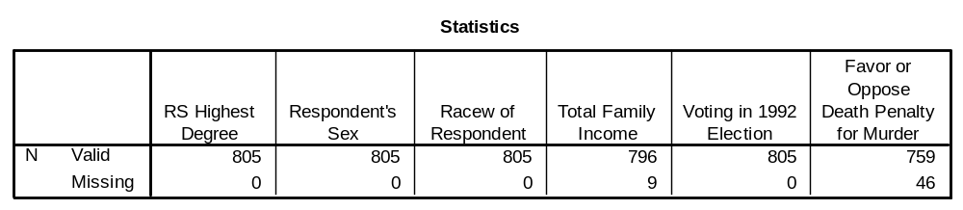

Frequency Table

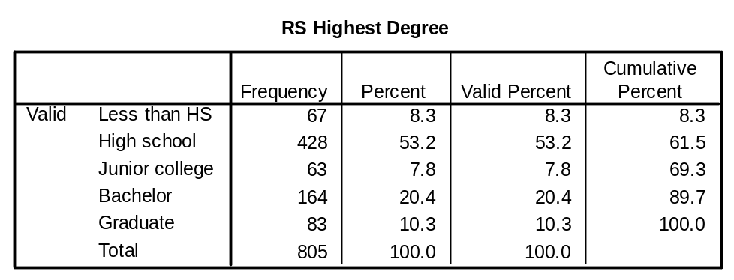

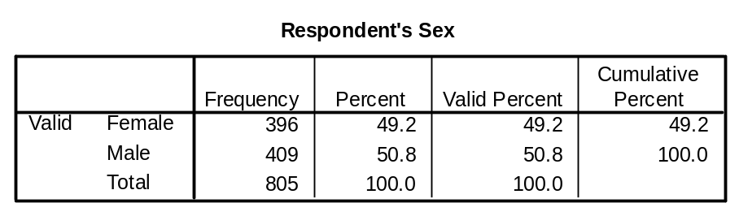

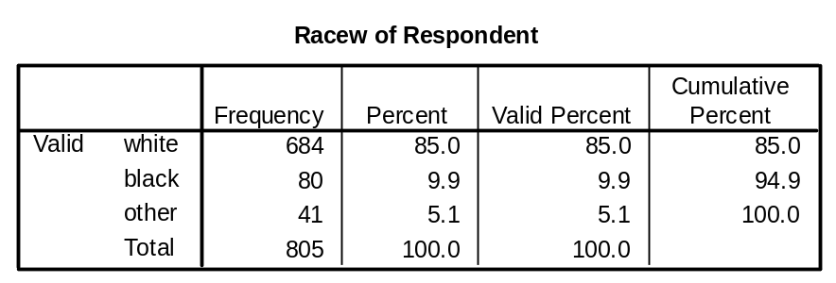

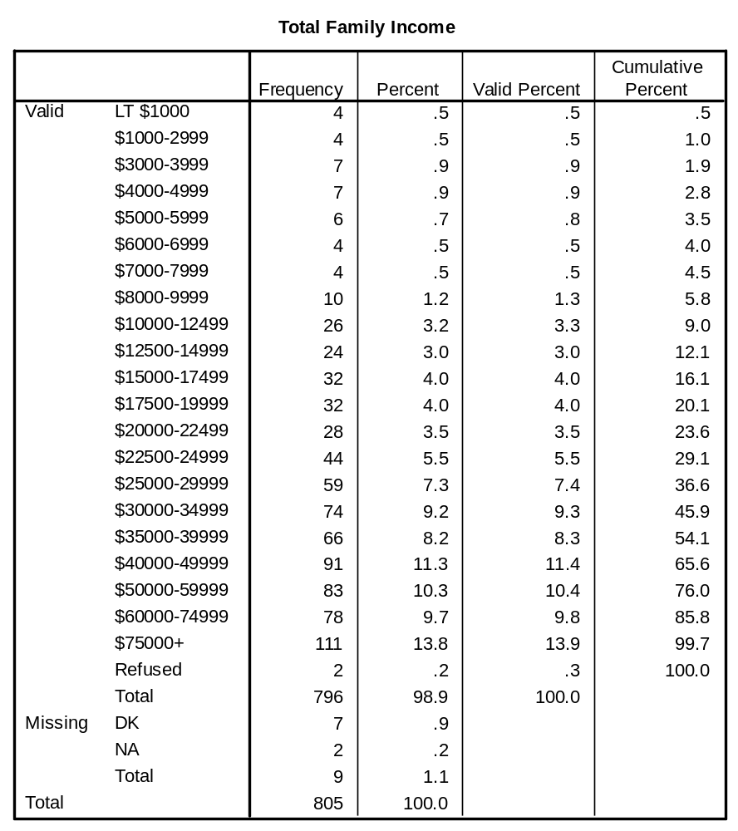

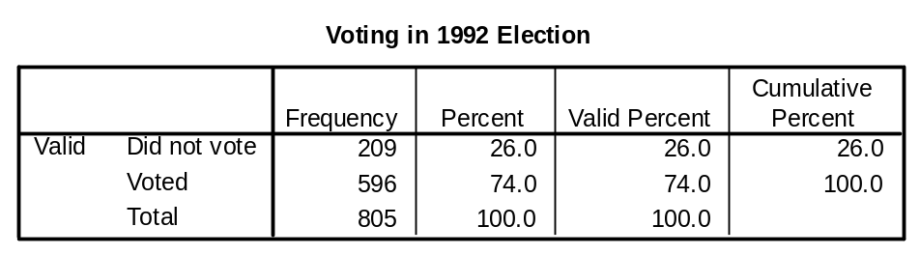

About 75% voted.

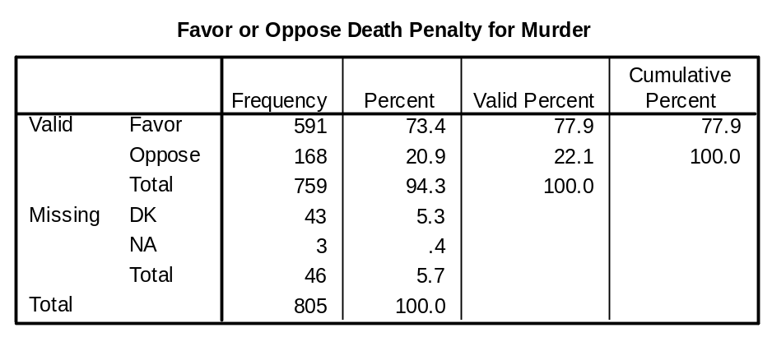

About 23% oppose.

Who is likely to vote?

LOGISTIC REGRESSION VARIABLES vote92
/METHOD = ENTER degree sex race income91
/CONTRAST (degree)=Indicator(1) /CONTRAST (race)=Indicator /CONTRAST
(sex)=Indicator(1)
/CASEWISE OUTLIER(2)
/PRINT = GOODFIT ITER(1) CI(95)
/CRITERIA = PIN(.05) POUT(.10) ITERATE(20) CUT(.5) .

Logistic Regression

[DataSet1] C:\Documents and Settings\matsuoh\My Documents\RM530\Data\GSS 1993 subset (logistic regression).sav

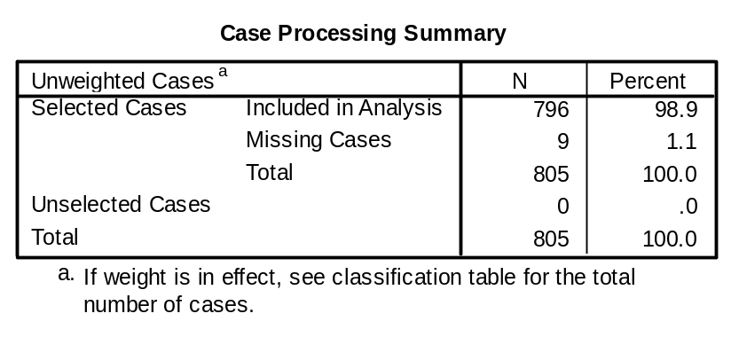

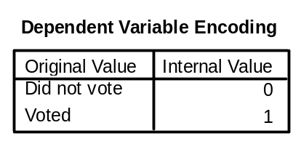Higher value is converted to 1 automatically.
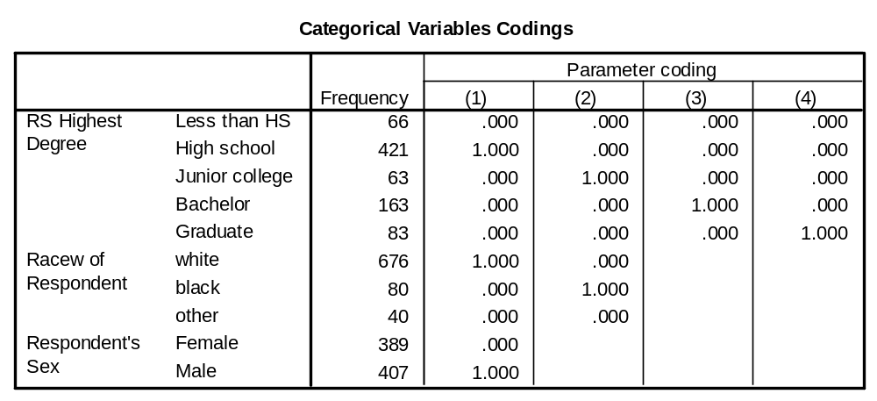

For Education, Less than HS is used as a reference category.
For Race, Other is a reference category, and for Sex, Female.

Block 0: Beginning Block

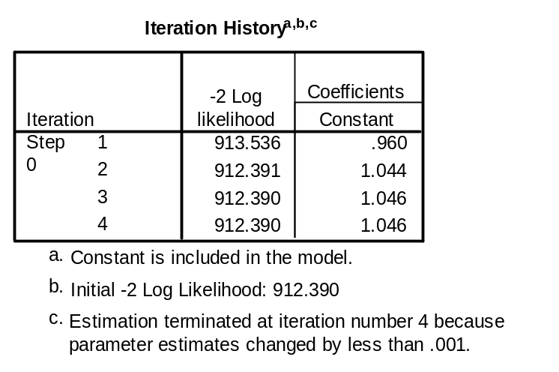

H₀ : Model=Data (Goodness-of-fit of the model)

Likelihood /chance is <1.0

When Likelihood = 1, there is a perfect fit between the model and data.

In logistic regression, Likelihood ratio chi-square is multiplied by -2Log.

When Likelihood=1, then -2LL=0. As Likelihood decreases, -2LL increases.

In sum, we are looking for a small -2LL.

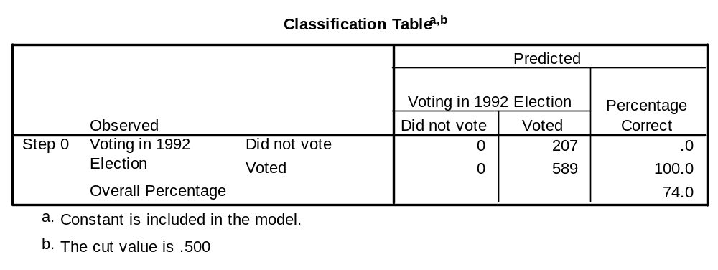
Without predictor variables (IVs), those who did not vote are not correctly classified.

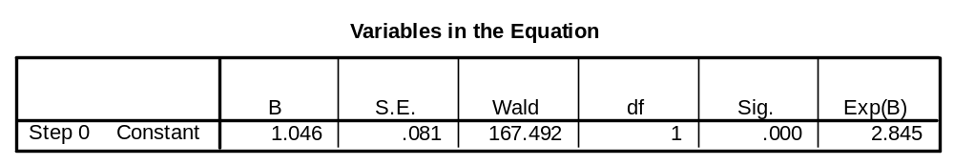

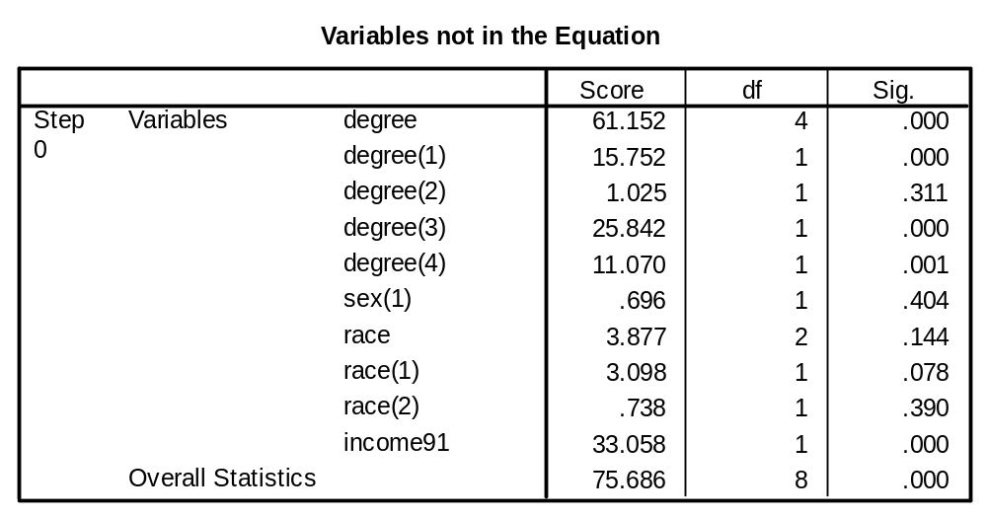

Df=8.

By adding one extra variable, you loose one DF.

Block 1: Method = Enter

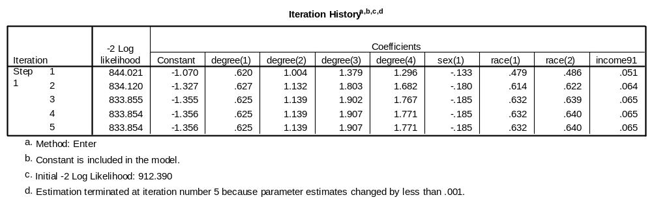

Fifth iteration provided a solution with -2LL=833.854.

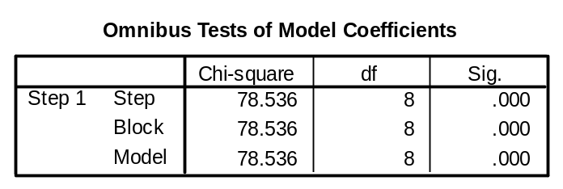

Model fit suggests that one or more IVs predict the outcome of DV because p<0.001.

912.390-833.854=78.536 with df=8.
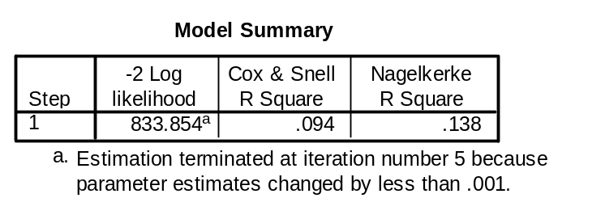
About 13.8% of the variance of outcome is explained by IVs.

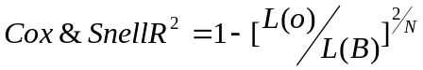

L(o)= Model to be tested
L(B)= Basic model/only constant

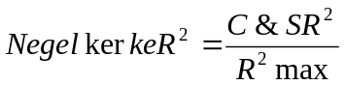

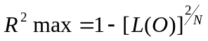

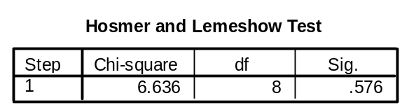

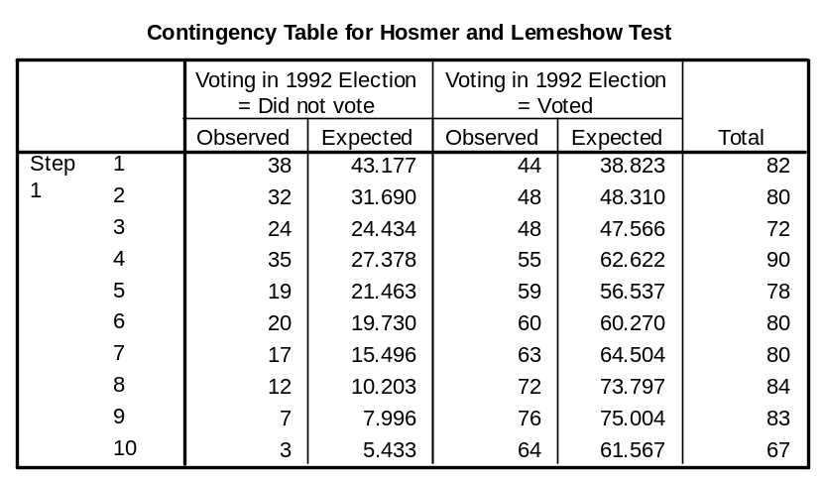

Hosmer-Lemeshow test suggests that there is a good model fit (there is a fit between observed and expected frequencies).

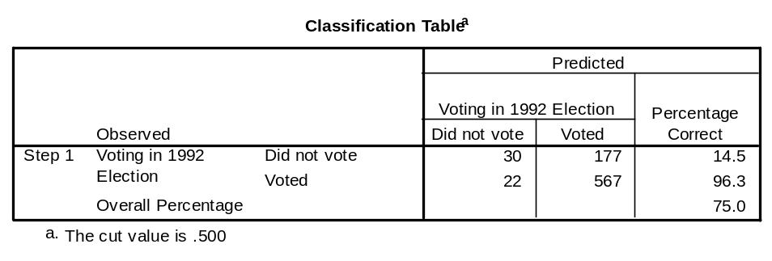

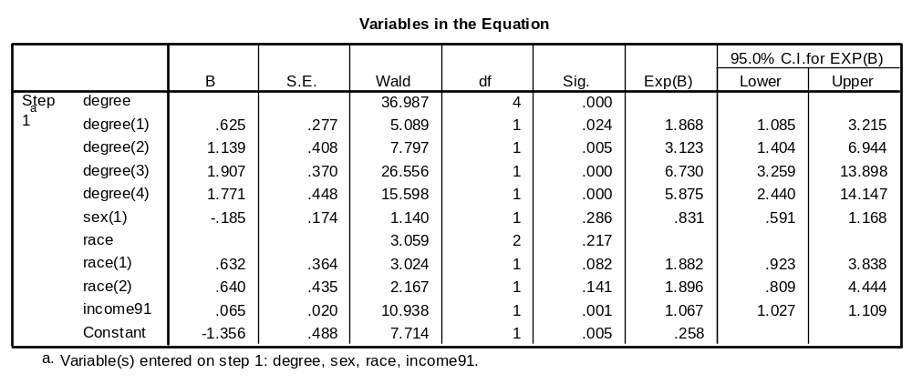

Educational degree and family income (social class) have significant impacts on voting pattern.

Reference categories: < high school, other race, and female

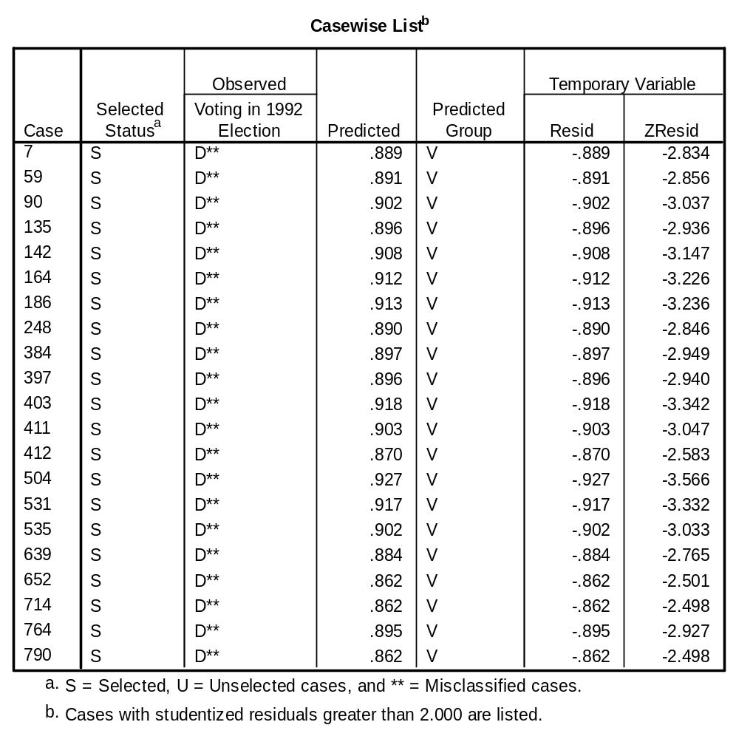

Predicted Probability (Odds ratio) given a certain profile

e.g. a: sex, b: age, c: education

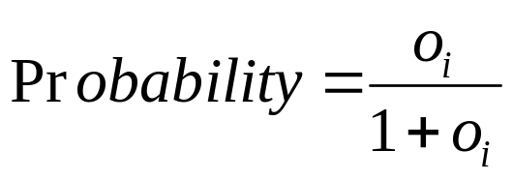

What is the probability for a white female who holds a graduate degree with income ($12,000-$15,000) to vote?

Female=0, white=1, graduate degree=1, income level=10

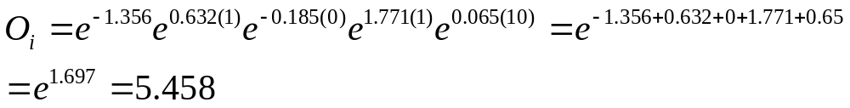

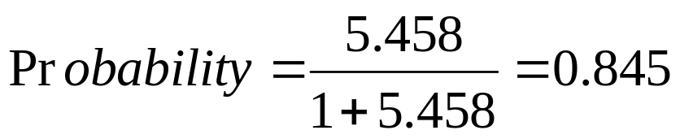

Probability for a white female who holds a graduate degree with income ($12,000-$15,000) to vote is 0.845 (84.5%)

Question

What is the probability for a male with racial background of black who holds high school degree with income about $30,000 (category 16) to vote?

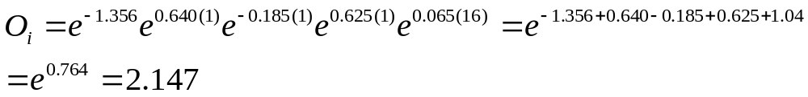

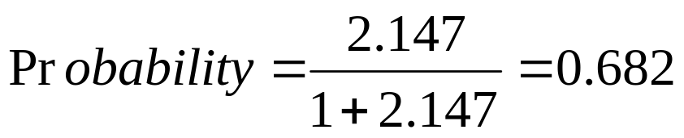

Who is likely to oppose capital punishment?

LOGISTIC REGRESSION VARIABLES cappun
/METHOD = ENTER degree sex race income91 age
/CONTRAST (degree)=Indicator(1) /CONTRAST (race)=Indicator /CONTRAST
(sex)=Indicator(1)
/CASEWISE OUTLIER(2)
/PRINT = GOODFIT ITER(1) CI(95)
/CRITERIA = PIN(.05) POUT(.10) ITERATE(20) CUT(.2) .

Logistic Regression

[DataSet1] C:\Documents and Settings\matsuoh\My Documents\RM530\Data\GSS 1993 subset (logistic regression).sav

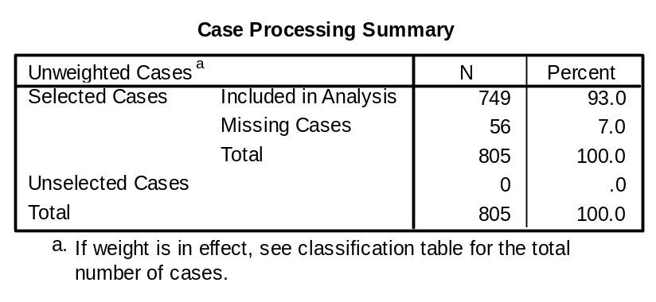

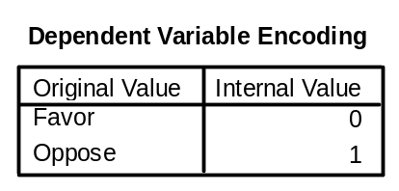

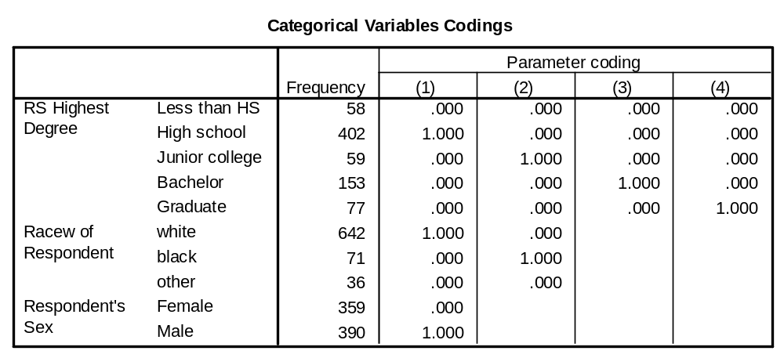

Block 0: Beginning Block

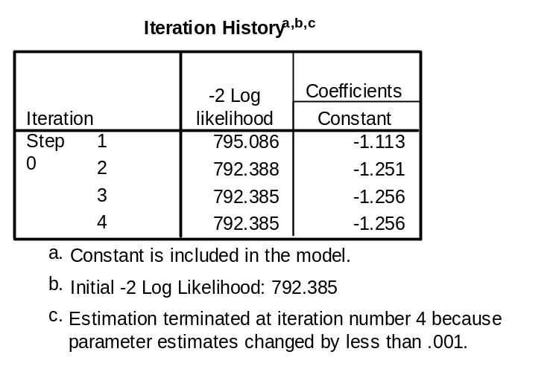

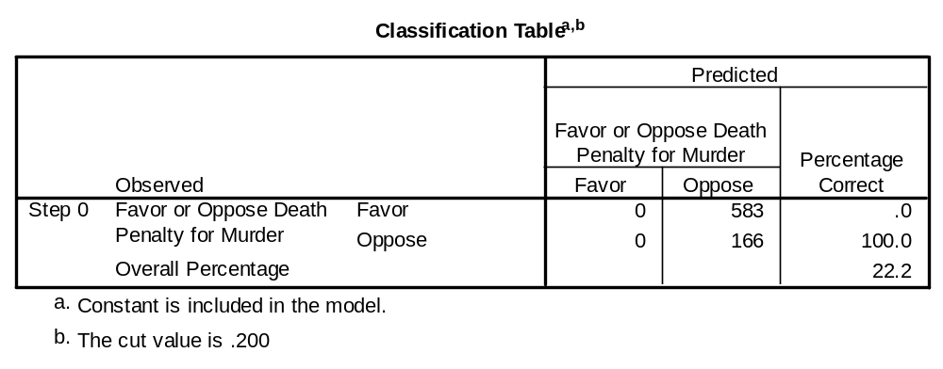

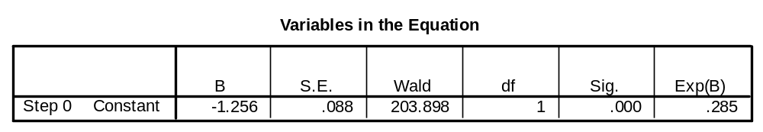

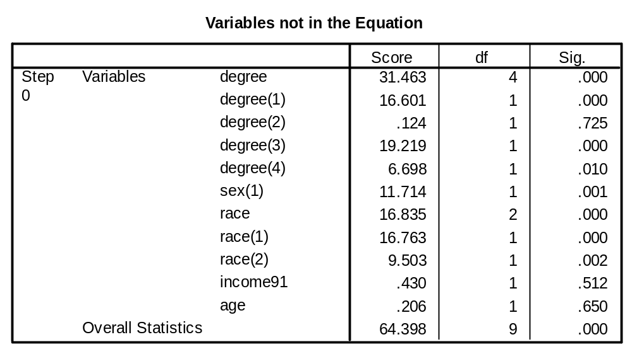

Block 1: Method = Enter

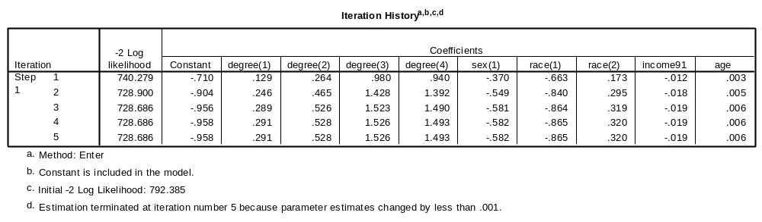

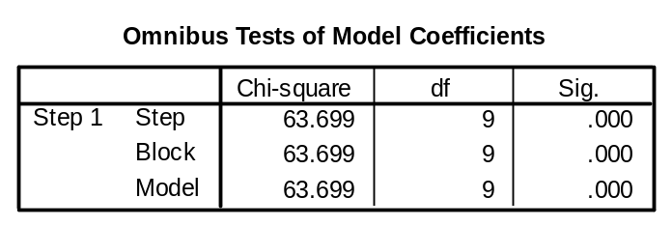

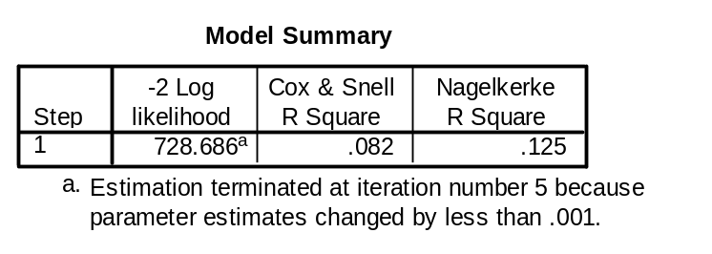

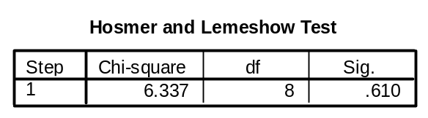

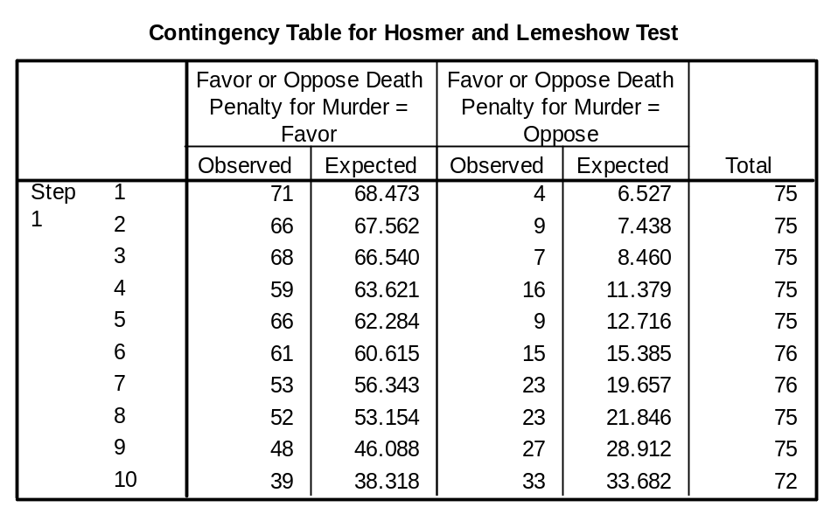

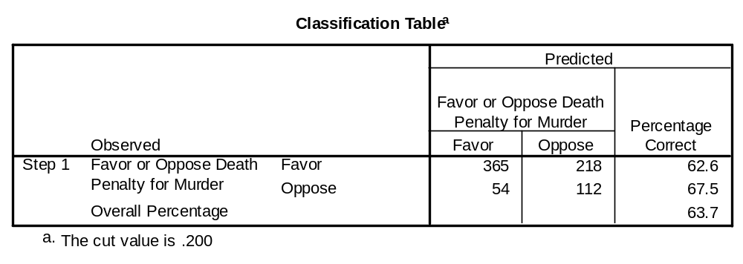

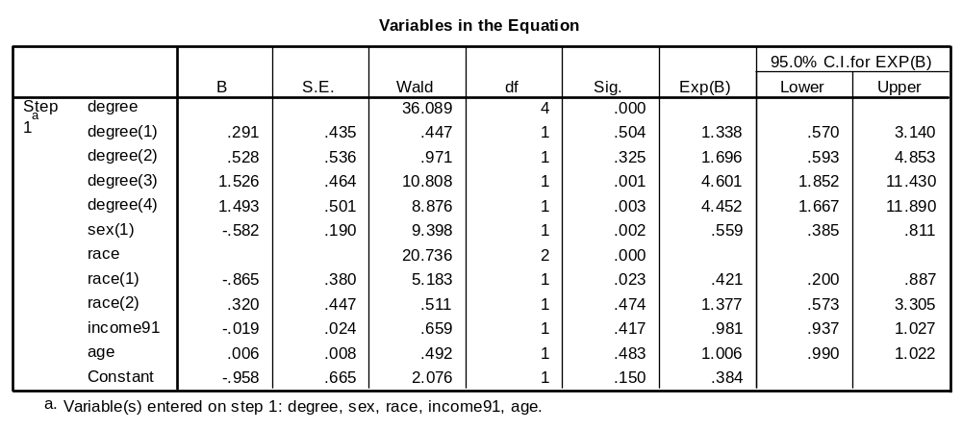

Questions

1. Describe the goodness-of-fit of the model.

2. How much % of the variation of DV is explained by the DVs?

3. What variables have impact on people’s opinion on capital punishment?
